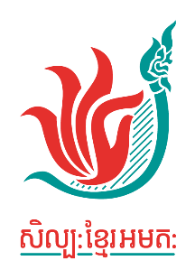

Mobility Grant
Application Form 2023

Your information

Family and Given Name: Date of birth ______ /______ /______
Gender: Woman Man Prefer not to say Other______
Address:

Mobile: Email
Company/Organization (If you work independently please write ‘not applicable’)
Position: (If applicable – no problem if not!))
Organization Address:
Back-up contact name:
Mobile

Education – Optional to complete

School(s) | Date of attendance | Qualification | Date of Graduation | Major / Field of Specialization

Previous projects/productions/research in Cambodia related to arts [if any] (Please do not adjust the size of the boxes.)

Brief employment history, beginning with the most recent

Information about the event

1) Event name:
2) Information about the event (Please share us a link if any)
(Please do not adjust the size of the boxes.)

3) What is the benefit of this program to you and the art and culture community of Cambodia?

4) Event location and date

- Budget requested (Please be detailed)

- Beside the financial support, do you need other supports to attend the event?

Cambodian Living Arts is committed to supporting the applicants regardless of discrimination, age, disability, indigenous, gender, family status, religion, and socio-economic status. Especially, we encourage candidates from the voiceless communities and we will support them (depending on their needs and necessary) to be successful candidates. If you wish to share any comments, please type in the box.

*The application form could be filled out by handwriting or by computer. If you have any issues to complete the application, please contact sinath@cambodianlivingarts.org or call 092 900 223

**Please attach a biography focusing your involvement in the arts (Max 1 page)

Signature of applicant: Date:

